从公司管理层 / 投资人视角分析越都粉碎机整体优势

（工程塑料/回收行业 含年度ROI能耗节约分析）

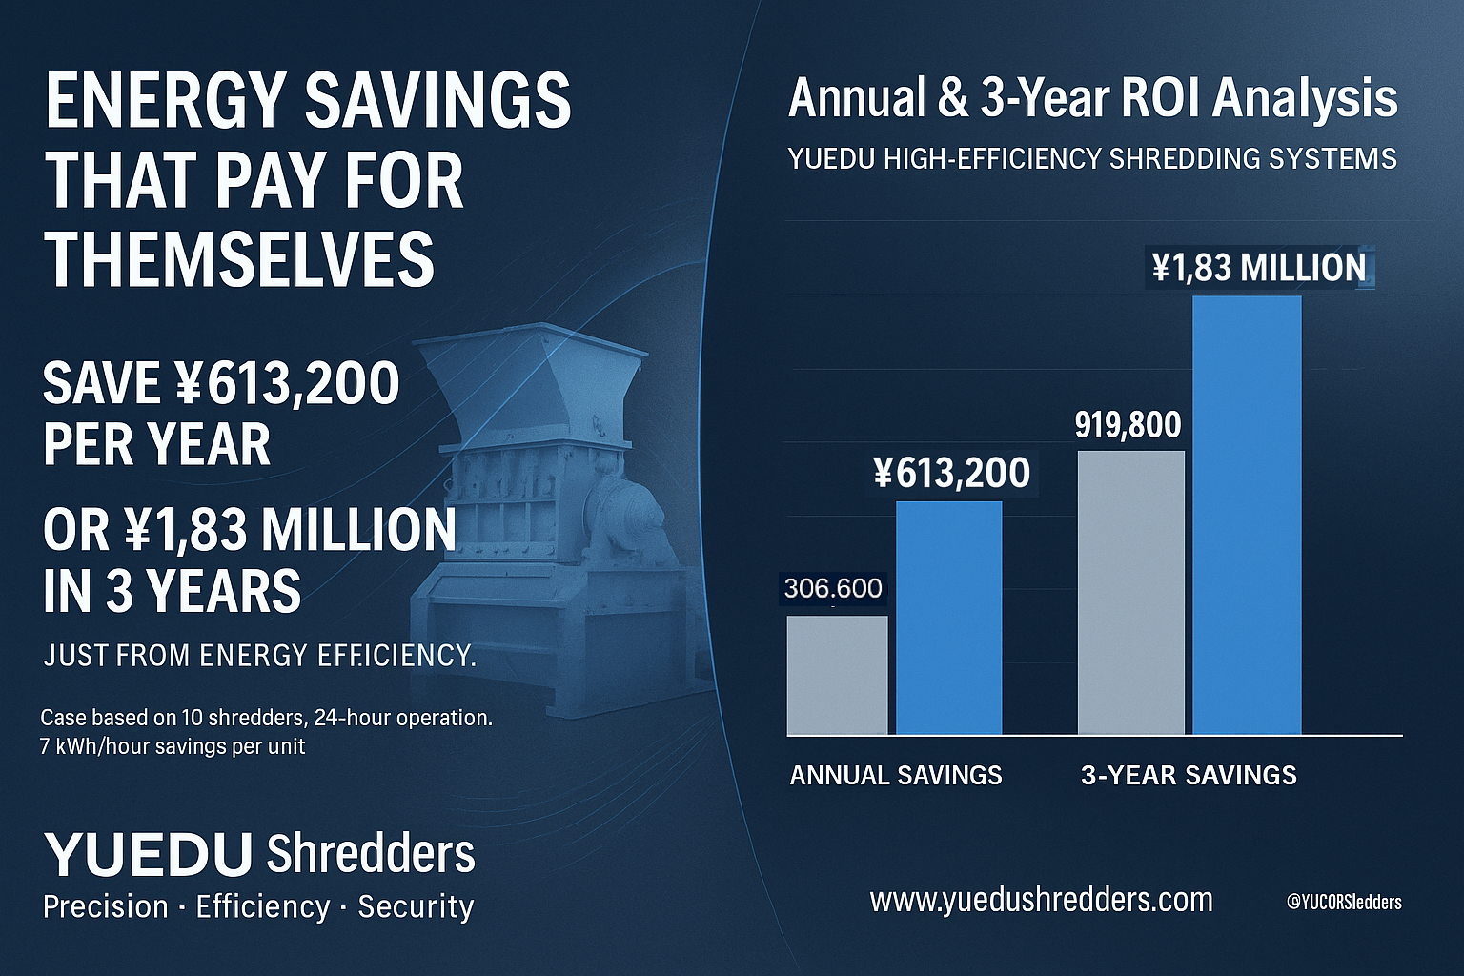
维度 | 客户痛点 | 越都粉碎机核心优势 | 为客户带来的效果与回报
① 管理省心 · 一站式交钥匙工程 | 普通设备采购后需反复协调安装、调试，管理层需长期关注运行问题。 | 越都提供“交钥匙工程”全流程服务：从需求调研、设计、制造、调试、交付到培训。 | 管理层可专注战略事务而非设备事务，节省时间与沟通成本。
② 环境与健康风险控制 · EHS合规 | 普通粉碎机粉尘外溢严重，尤其玻纤、碳纤材料，对人体有毒；跨国公司将面临员工诉讼、品牌危机与巨额赔偿。 | 全密封结构 + 静电消除 + 高效除尘系统，粉尘外逸率极低。符合ISO与全球EHS标准。 | 保护员工健康，防止诉讼与罚款；  满足ISO、EHS审计要求，保护企业品牌与维护市值。
③ 能耗控制与长期成本节约 | 普通设备能耗高、温升大、运行成本长期累积高。 | 高效刀具结构 + 节能电机设计，单位能耗降低20%–40%。 | ⚡ 年度ROI实例（能耗节约回报）  • 单台设备每小时省电7度  • 工厂配10台 → 每小时省70度电  • 每年节电量：613,200度电 ≈ 61.32万元/年  •三年累计节省：1,839,600度电 ≈ 183.96万元  👉 仅能耗一项，3年即可节省近183万元
④ 稳定性与维护成本 | 设备故障率高、刀具易损、停机频繁；维修依赖少数技术工人，形成“人质化”管理风险。 | 丰富行业经验和设计能力。采用高耐磨钢，结构模块化设计，易于维护，支持长期连续工作。 | 减少停机与人工依赖，降低维护成本50%以上。
⑤ 产量效能与时间回报 | 普通设备产能低，同样工作量需更长时间完成；能耗与人工浪费严重。 | 同功率设备下产量高出30%~60%；粉碎结构优化。 | 同样工作量可节省50%以上时间与能耗，实现更高产能回报。
⑥ 绿色制造与企业ESG | 粉尘多、噪音大、废料难回收，影响ISO14001体系与ESG目标。 | 封闭除尘系统 < 68 dB 静音设计 + 闭环回收系统。 | 支持绿色生产、ESG合规及ISO认证要求，提升企业社会责任形象。

📈 管理层总结（Managerial Summary）
对企业老板 / 总经理：
选择越都粉碎机 = 选择 省心、省电、省钱、省风险 的投资回报系统。
它不仅是设备，更是企业降本增效与品牌护城河的组成部分。

Managerial & Investor-Level Advantages of YUEDU Shredding Systems

(Engineering Plastic / Recycling Industry | With ROI Energy-Saving Comparison)
Dimension | Pain Points | YUEDU Shredders’ Core Advantage | Customer Value & ROI
① Turnkey Project – Worry-Free Management | Traditional machines require repeated coordination and on-site supervision by management. | YUEDU provides a Turnkey Solution covering research, design, manufacturing, commissioning, delivery, and training. | Management can focus on strategic goals instead of daily equipment issues — saving time and communication cost.
② EHS Compliance & Health Protection | Conventional shredders release dust, especially from glass fiber and carbon fiber, which is harmful to workers and may cause lawsuits or fines. | Fully enclosed shredding chamber with static elimination and efficient dust collection. Certified under ISO and global EHS standards. | Protects workers’ health, avoids lawsuits and penalties, and strengthens corporate reputation and compliance.
③ Energy Efficiency & Long-Term Cost Reduction | High energy consumption and heat buildup lead to significant long-term operating costs. | Optimized cutting design and high-efficiency motor reduce energy use by 20%–40%. | ⚡ Annual ROI Example (Energy-Saving ROI)  • Each machine saves 7 kWh/hour  • 10 machines → 70 kWh/hour saved  • 24 hours/day → 1,680 kWh/day saved  • 365 days/year → 613,200 kWh saved ≈ ¥613,200 per year  • 3-Year saving: 1,839,600 kWh ≈ ¥1,839,600  👉 Energy savings alone reduce annual costs by ¥1830,000, quickly recovering equipment investment.
④ Reliability & Maintenance Cost | Frequent failures and downtime cause production interruptions and dependence on limited technicians. | High-chromium wear-resistant blades, modular design, and 24-hour continuous operation capability. | Reduces downtime and maintenance dependency by over 50%.
⑤ Productivity & Efficiency ROI | Low output and slow speed increase electricity and labor costs. | 30%–60% higher throughput at the same power level; high-torque flywheel ensures efficient operation. | Saves 50% of time and power per workload, improving total line ROI.
⑥ Sustainability & ESG Alignment | Dust, noise, and poor waste management lower ISO 14001 and ESG ratings. | <68 dB low-noise design with enclosed dust extraction and closed-loop recycling system. | Enables green production, improves ESG disclosure, and enhances corporate social responsibility image.

Managerial Summary
Choosing YUEDU Shredders means choosing Peace of Mind, Power Efficiency, Cost Savings, and Risk Reduction.
It’s not just a machine — it’s a long-term ROI asset and a foundation of operational excellence.

🌐 Contact Us
Shanghai YUEDU Technology Co., Ltd.
📞 Contact Us to explore more customized models and tailored shredding solutions that suit your specific needs!
Let us help you find the perfect equipment for your application.
📱 Sales Supervisor: +86 159 0178 2779 (WhatsApp / WeChat / Facebook)
📱 Administrative Supervisor: +86 137 6138 5116
📧 Email: yuedushredders@gmail.com | denghao8410@gmail.com
🌐 Website: www.yuedushredders.com
@YUEDUShredders – Empowering Global Industries with Intelligent Destruction Systems.

